Lab Manual for Software Construction and Development -SESD3241
Lab Manual-1-Fall 2024
SCD LAB Booklet



Faculty of Information Technology
UCP Lahore Pakistan

Contents
Lab 01 3
What is UML? 3
Components of the UML: 3
UML Diagrams: 3
What is StarUML? 4
StarUML Interface: 5
Star UML: Adding diagram: 6
Class Diagram 7
https://docs.staruml.io/working-with-uml-diagrams/class-diagram 7
Object Diagram 8
Use case Diagram 9
Sequence Diagram 10
Class Exercise: 11

Lab 01
Topic | Introduction to Design Phase
Objective | - Brief Introduction of UML  - Revision of UML Diagrams (Class Diagram, Object Diagram, Use case Diagram, Sequence Diagram)  - Introduction to tool – Star UML

What is UML?
UML is a standard language for specifying, visualizing, constructing, and documenting for large software systems, as well as for business modeling and other non-software systems.
UML uses graphical notations to express design of software projects and its requirements.

Components of the UML:
The UML consists of a number of graphical elements that combine to form diagrams. UML is a language; it has rules for combining these elements. The purpose of the diagrams is to present multiple views of a system; this set of multiple views is called a model. A UML model tells what a system is supposed to do.

UML Diagrams:
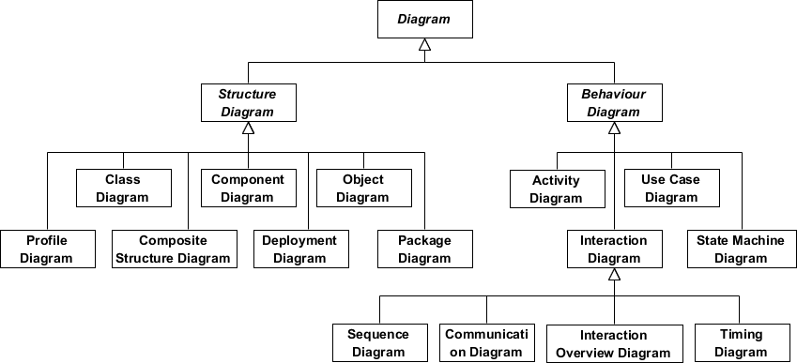
- Structure diagrams show the static structure of the system and its parts on different abstraction and implementation levels and how they are related to each other. The elements in a structure diagram represent the meaningful concepts of a system, and may include abstract, real world and implementation concepts.

- Behavior diagrams show the dynamic behavior of the objects in a system, which can be described as a series of changes to the system over time.

What is StarUML?
StarUML™ is a software modeling platform that supports UML (Unified Modeling Language).

Downloading StarUML: Download StarUML from the website https://staruml.io/.
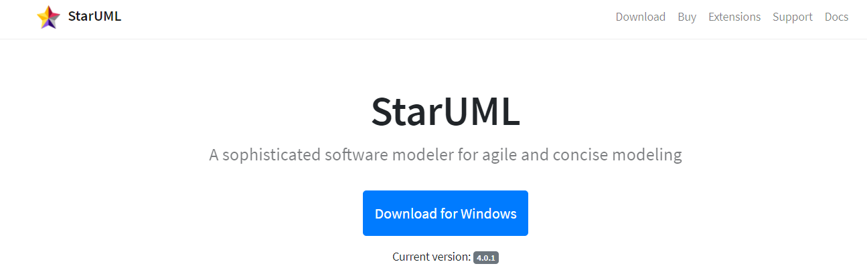

Installing StarUML: Run the setup to install StarUML
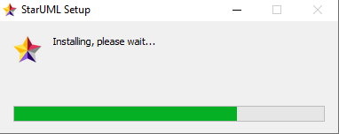

StarUML Interface:

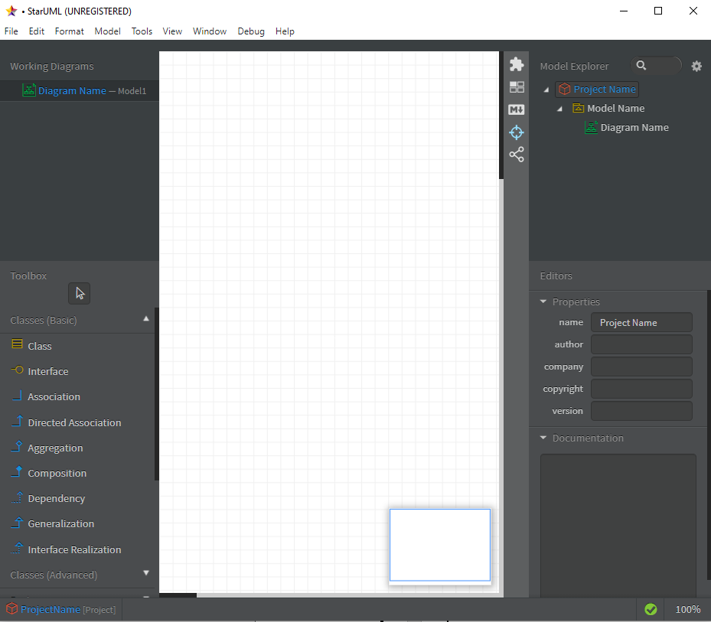

Star UML: Adding diagram:

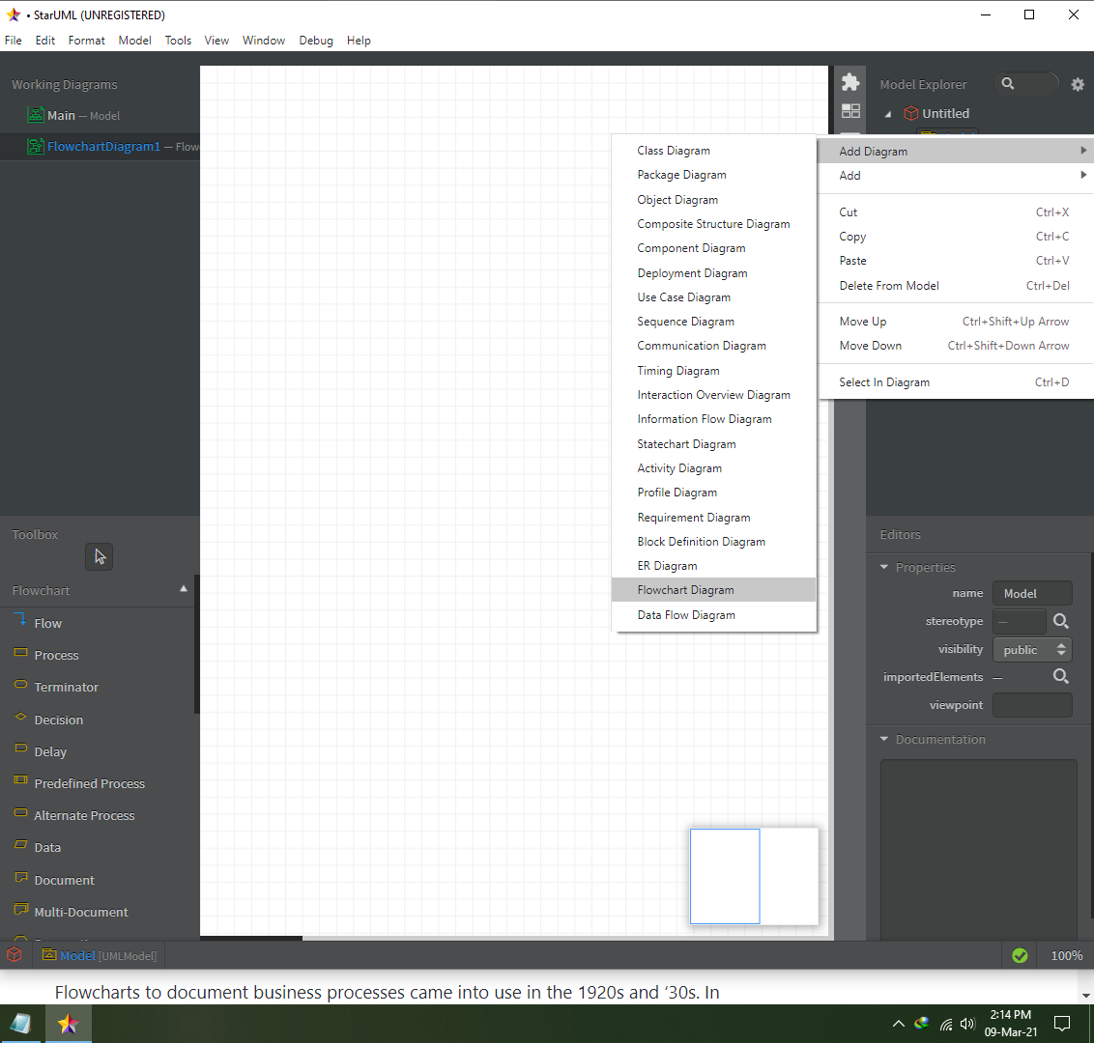

Class Diagram
A class diagram in the Unified Modeling Language (UML) is a type of static structure diagram that describes the structure of a system by showing the system's classes, their attributes, operations (or methods), and the relationships among objects.

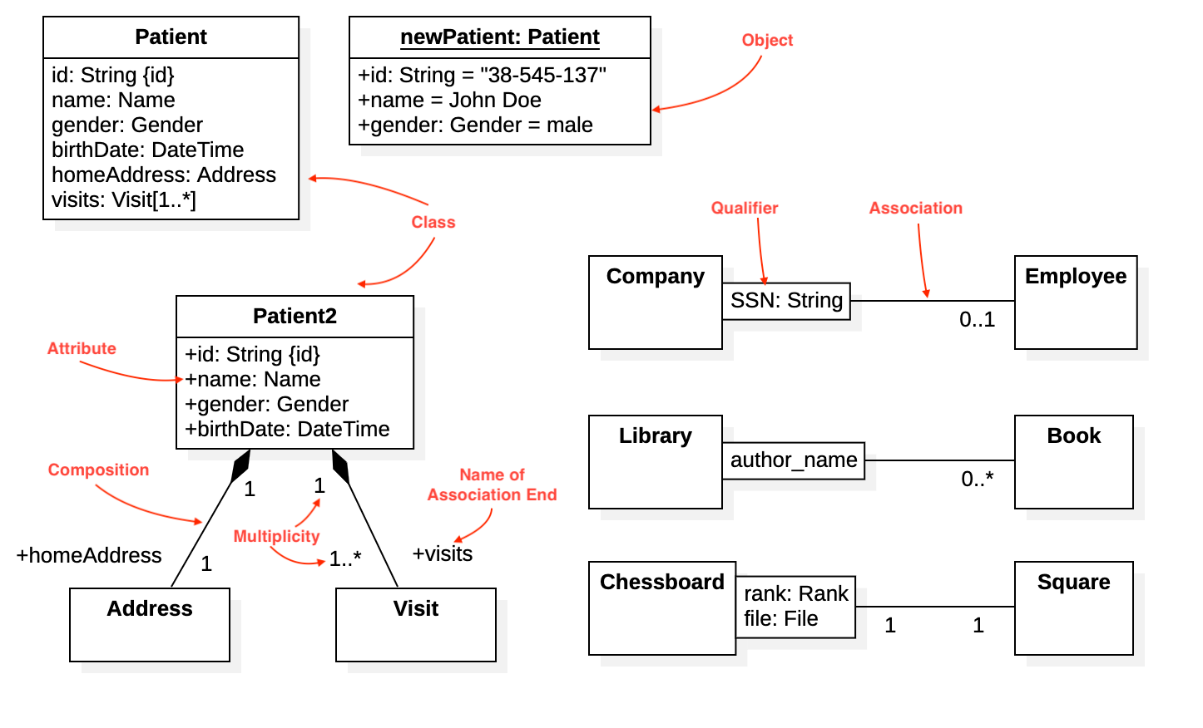

https://docs.staruml.io/working-with-uml-diagrams/class-diagram

Object Diagram
Object is an instance of a class in a particular moment in runtime that can have its own state and data values. Likewise, a static UML object diagram is an instance of a class diagram; it shows a snapshot of the detailed state of a system at a point in time, thus an object diagram encompasses objects and their relationships which may be considered a special case of a class diagram.

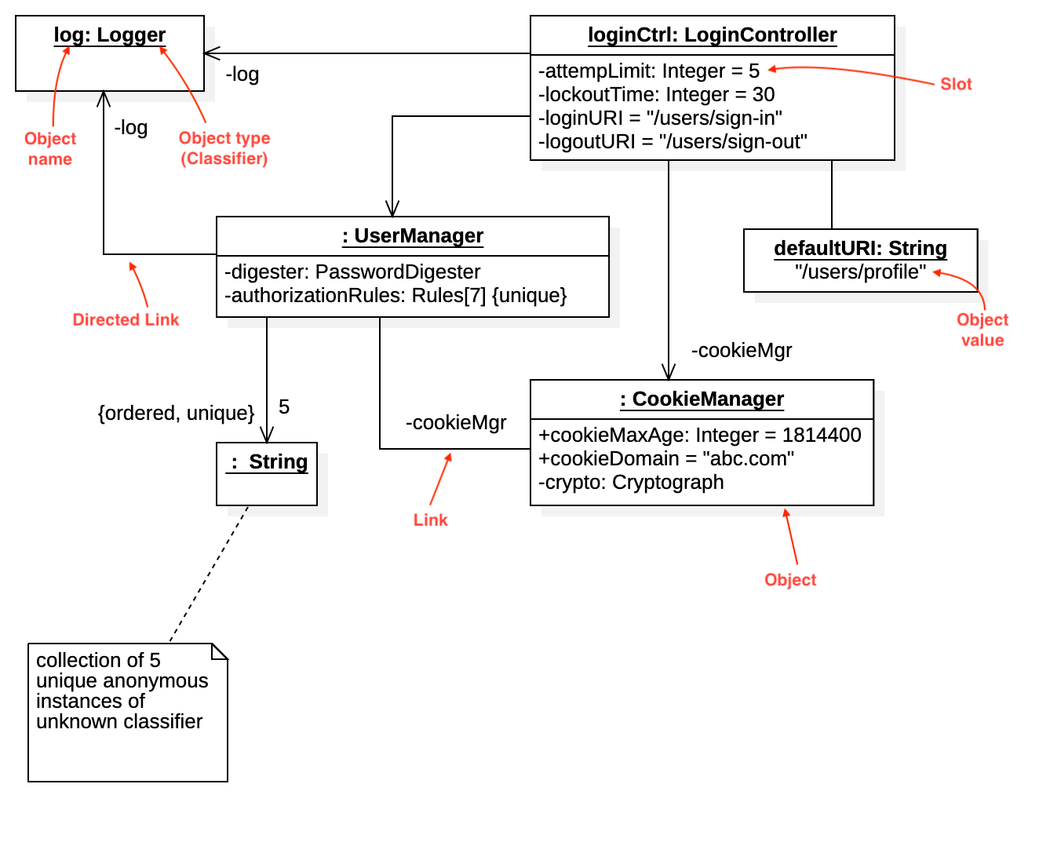

https://docs.staruml.io/working-with-uml-diagrams/object-diagram

Use case Diagram
A UML use case diagram is the primary form of system/software requirements for a new software program underdeveloped. Use cases specify the expected behavior (what), and not the exact method of making it happen (how). A key concept of use case modeling is that it helps us design a system from the end user's perspective. It is an effective technique for communicating system behavior in the user's terms by specifying all externally visible system behavior.

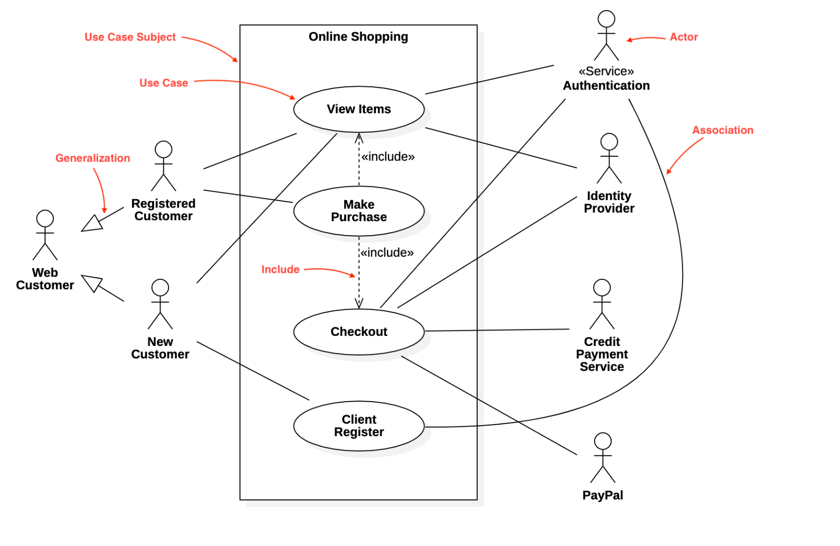

https://docs.staruml.io/working-with-uml-diagrams/use-case-diagram

Sequence Diagram
UML Sequence Diagrams are interaction diagrams that detail how operations are carried out. They capture the interaction between objects in the context of a collaboration. Sequence Diagrams are time focus and they show the order of the interaction visually by using the vertical axis of the diagram to represent time what messages are sent and when.

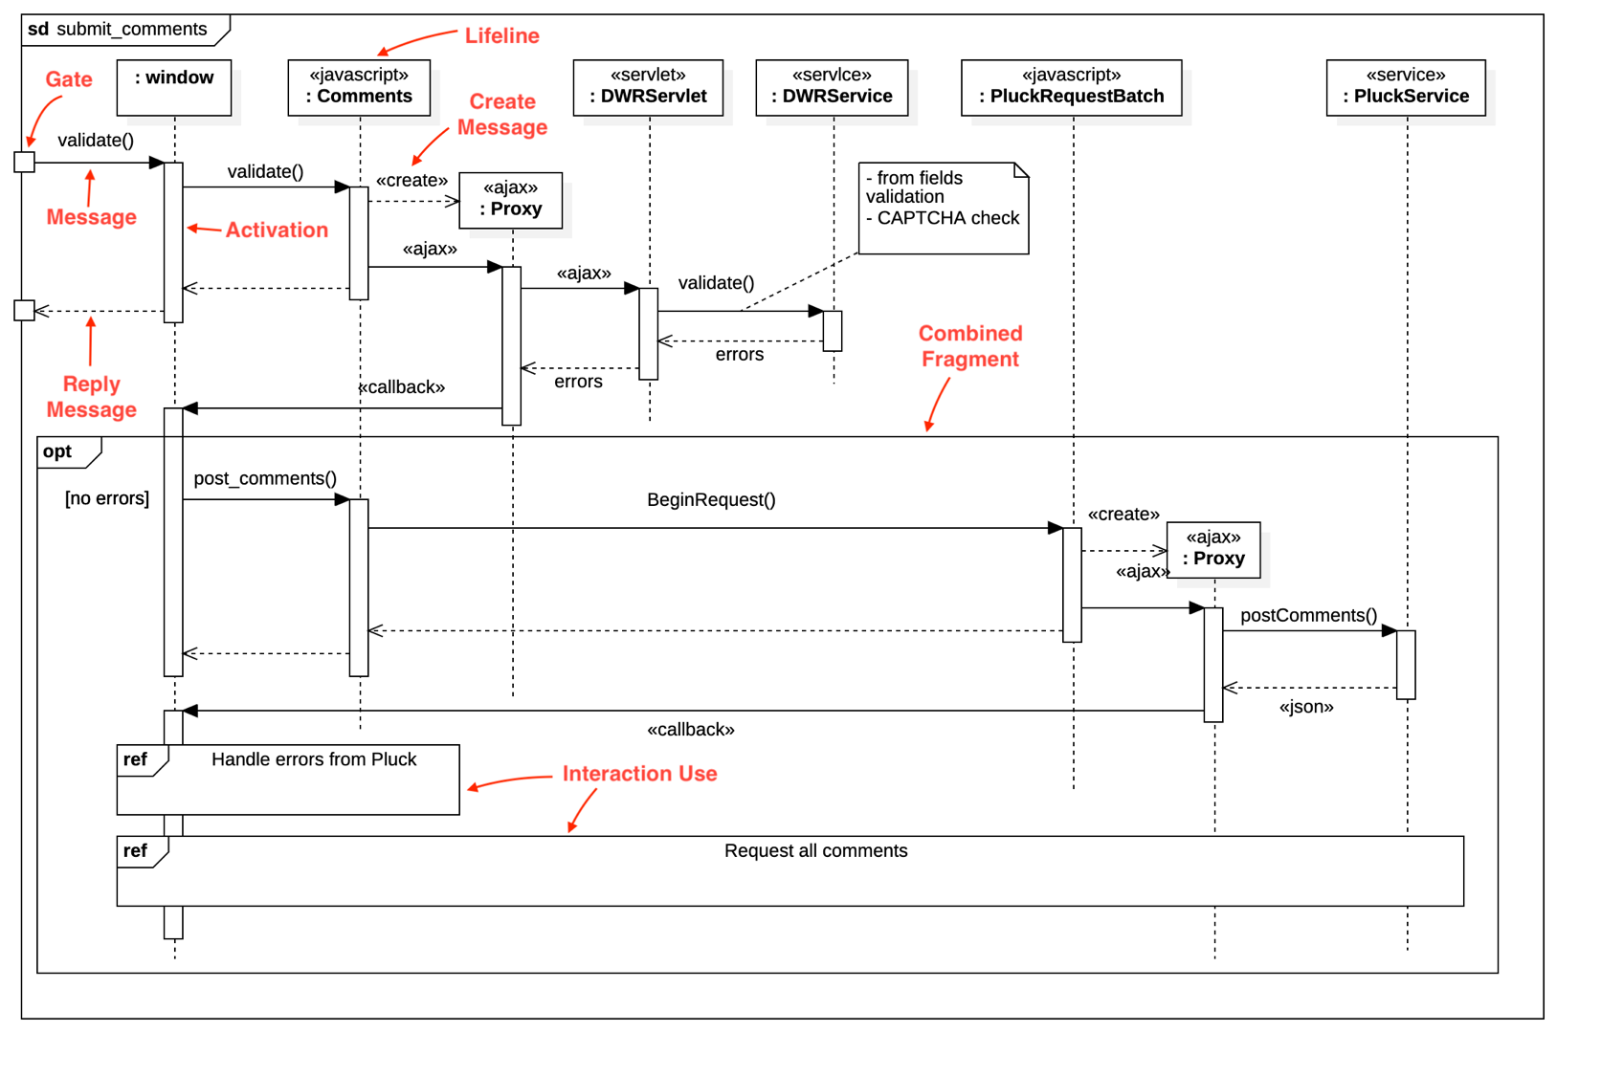
https://docs.staruml.io/working-with-uml-diagrams/sequence-diagram

Class Exercise:

Publishing company produces scientific books on various subjects. The books are written by authors who specialize in one particular subject. The company employs editors who, not necessarily being specialists in a particular area, each take sole responsibility for editing one or more publications. A publication covers essentially one of the specialist subjects and is normally written by a single author. When writing a particular book, each author works with on editor, but may submit another work for publication to be supervised by other editors. To improve their competitiveness, the company tries to employ a variety of authors, more than one author being a specialist in a particular subject.
Considering the above stated scenario, draw below diagrams
- use case Diagram
- Sequence Diagram
- Class Diagram

